**Linked-in-article URL –**

[**https://www.linkedin.com/posts/manasavvd_kluniversity-klcse-cloudcomputing-activity-6922949124363280384-TteB?utm_source=linkedin_share&utm_medium=member_desktop_web**](https://www.linkedin.com/posts/manasavvd_kluniversity-klcse-cloudcomputing-activity-6922949124363280384-TteB?utm_source=linkedin_share&utm_medium=member_desktop_web)

**Build a serverless web application on AWS Cloud to POST and GET Customer details from the dynamoDB with Email ID .**

**Procedure  
Step-1 :** GetEmploeeDetails

1. Create API gateway GET Method with integration type MOCK
2. Create a dynamo DB table with EmailID, FirstName, LastName as attributes
3. Create a Lambda function to get the details from the table
4. Integrate the lambda function to the API gateway
5. Test using postman
6. Paste the invoke url in the index.html file

**Step-2 :** PostEmployeeDetails

1. Create API gateway With GET Method with integration type MOCK
2. Create a lambda function with the code that fetches the data from the table
3. Integrate the lambda function to the API gateway
4. Test using postman
5. Paste the invoke url in the index.html file

**Step-3:** Host the website in the S3

**Step-4:** Copy the website url in the browser and check the execution

**Architecture:**

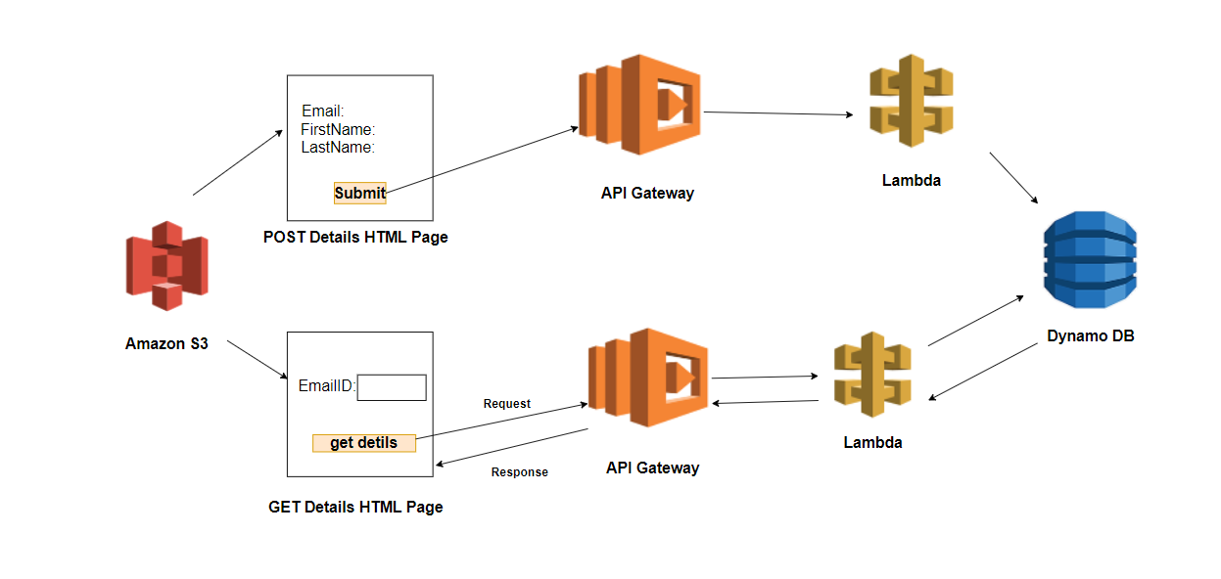

**GET Employee Details:**

1.Login to AWS Management console and search for API Gateway and click on that.

2. Click on create API and then choose REST Protocol

3. Choose New API , give it a name as shown in the below image and click on create API

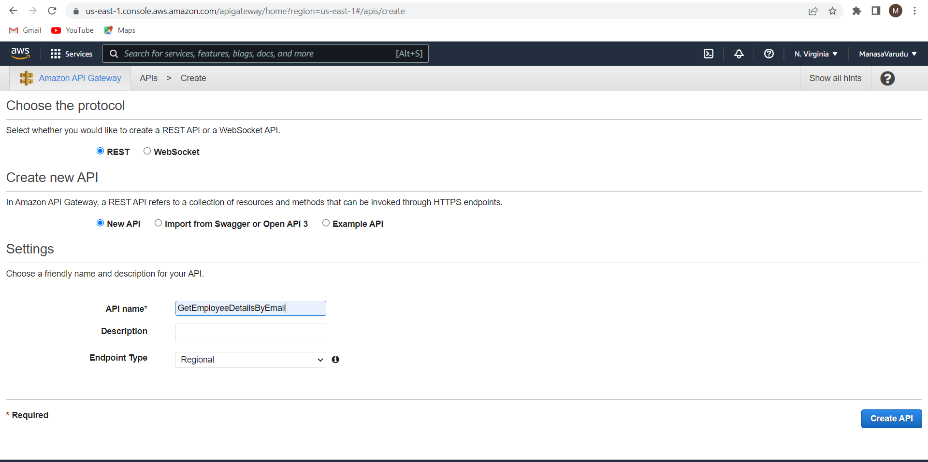

Once the API is created in the actions drop down click on create Resource.

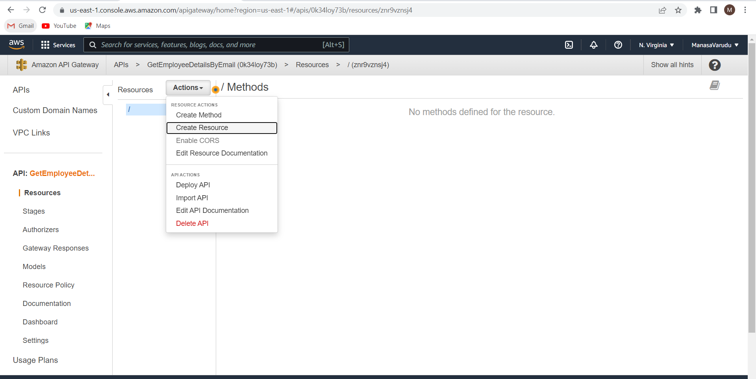

create a method GET inside that resource from the actions drop down.

Choose the integration type as Mock and click save.

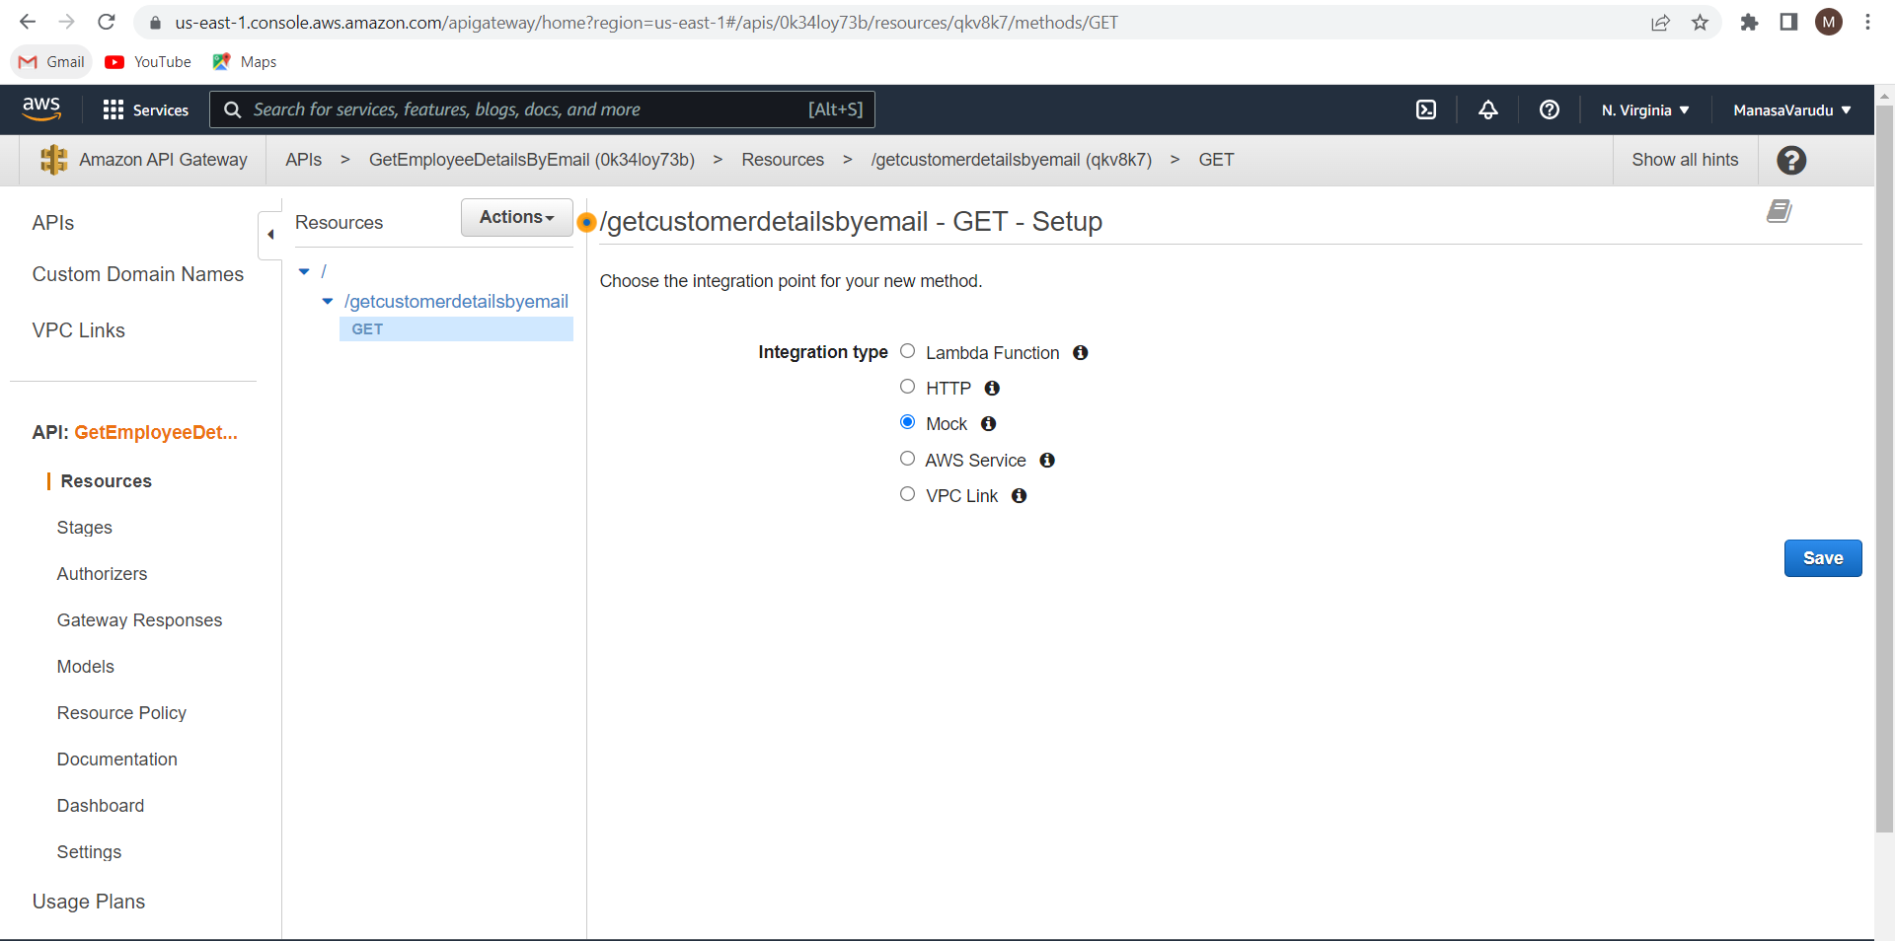

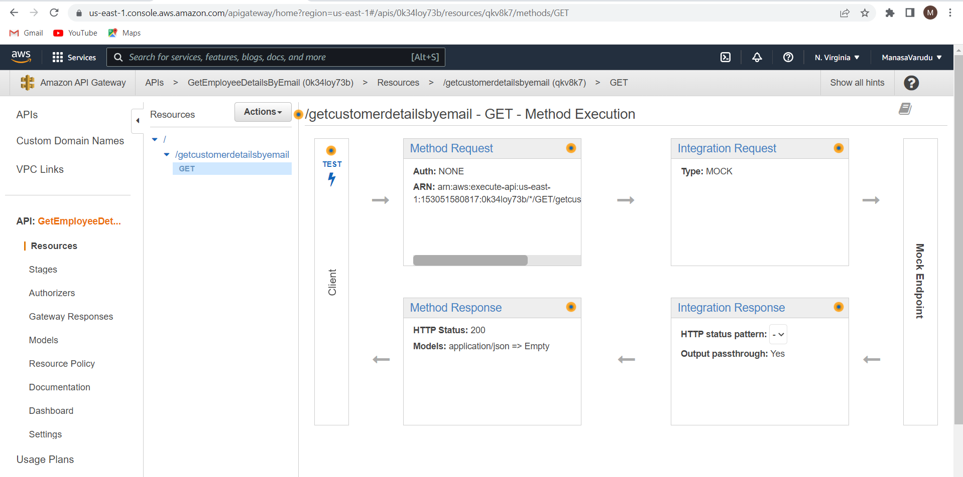

Now click on integration response under mapping templates edit the application/json.

Write the code as shown below and click on save.

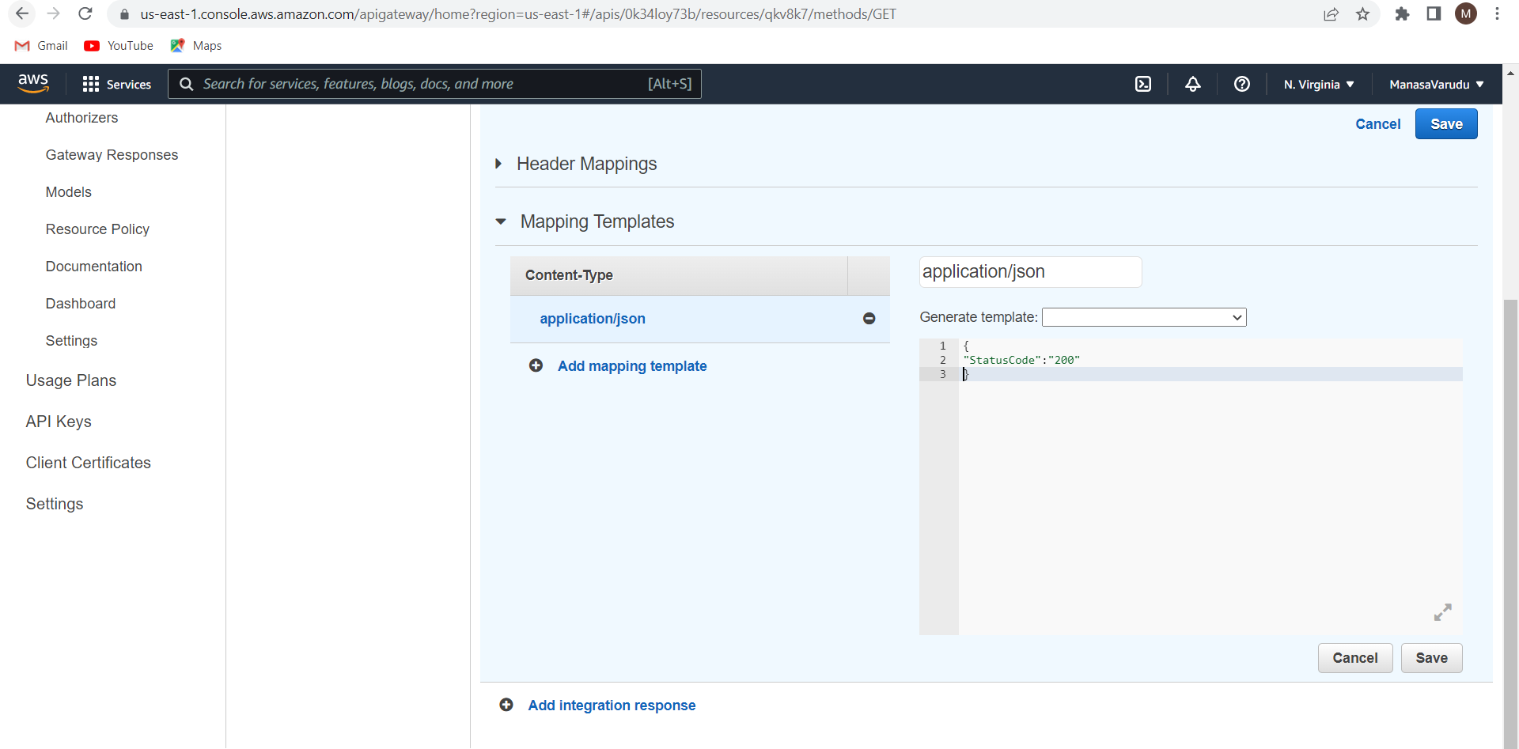

Form the actions drop down click on deploy API

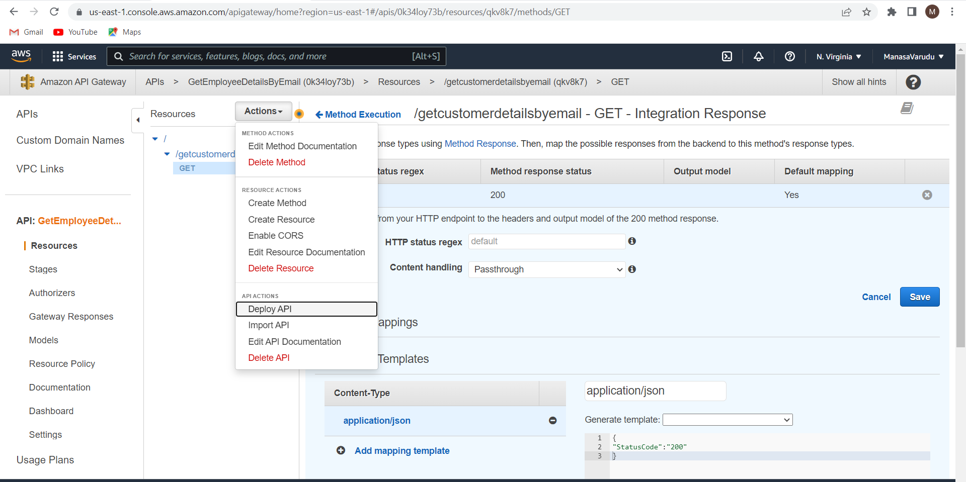

Enter the details as shown below and click on deploy.

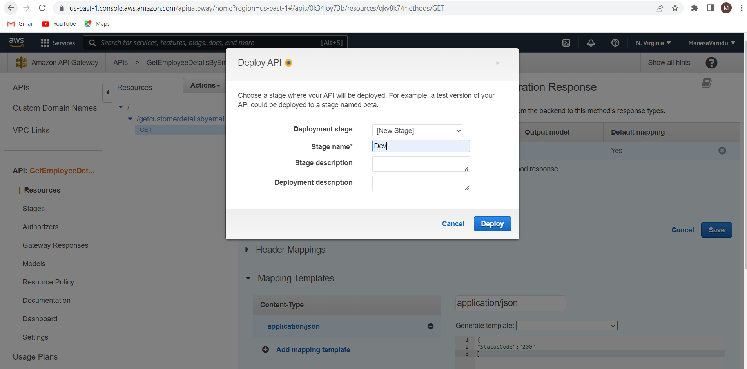

You will get the invoke url.

Copy this url .

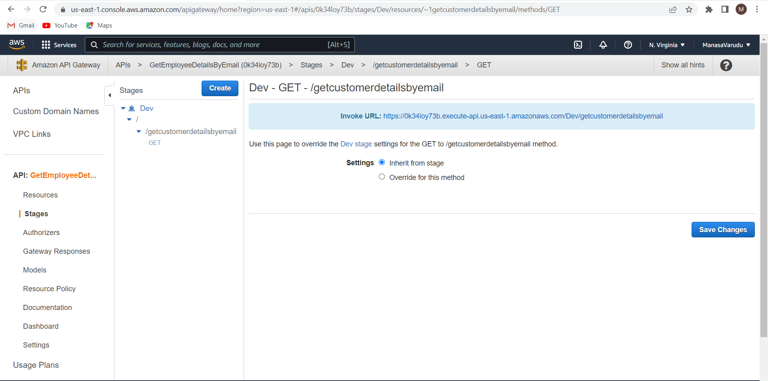

Goto postman web page login with your credentials .

Create a work space.

Click on the + symbol at the top and choose GET method from the dropdown.

Copy paste the invoke url in the space and click on send.

You will get the response as {statuscode:200} as sown in below image.

This indicates that your API is working fine.

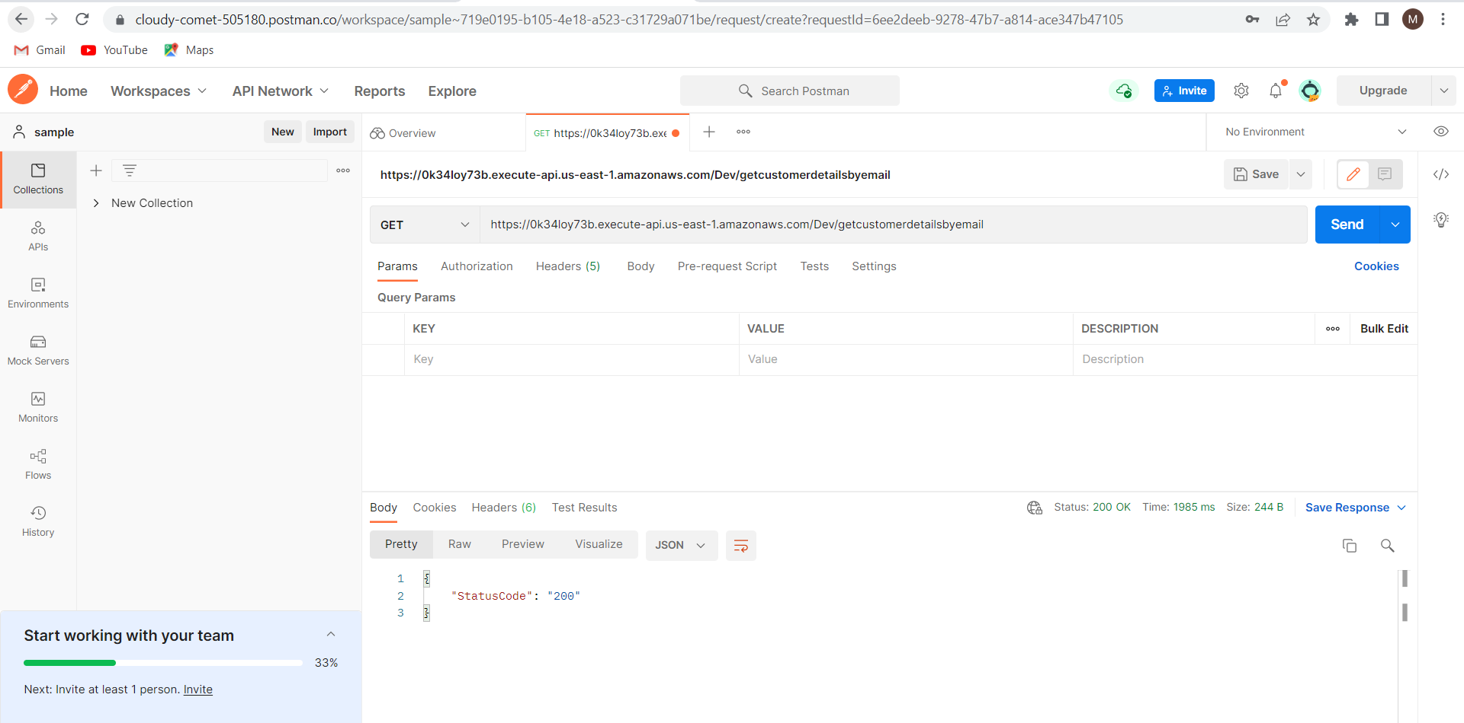

Create a table in the dynamo DB with attributes EmailID , FirstName, LastName.

Insert at least 1 record in to it.

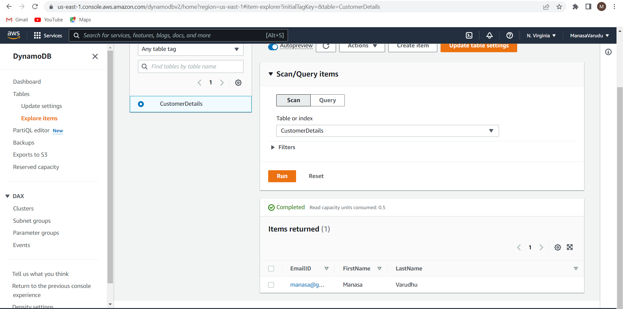

Create a IAM role with the permissions DynamoDB_FullAccess and Lambda_FullAccess.

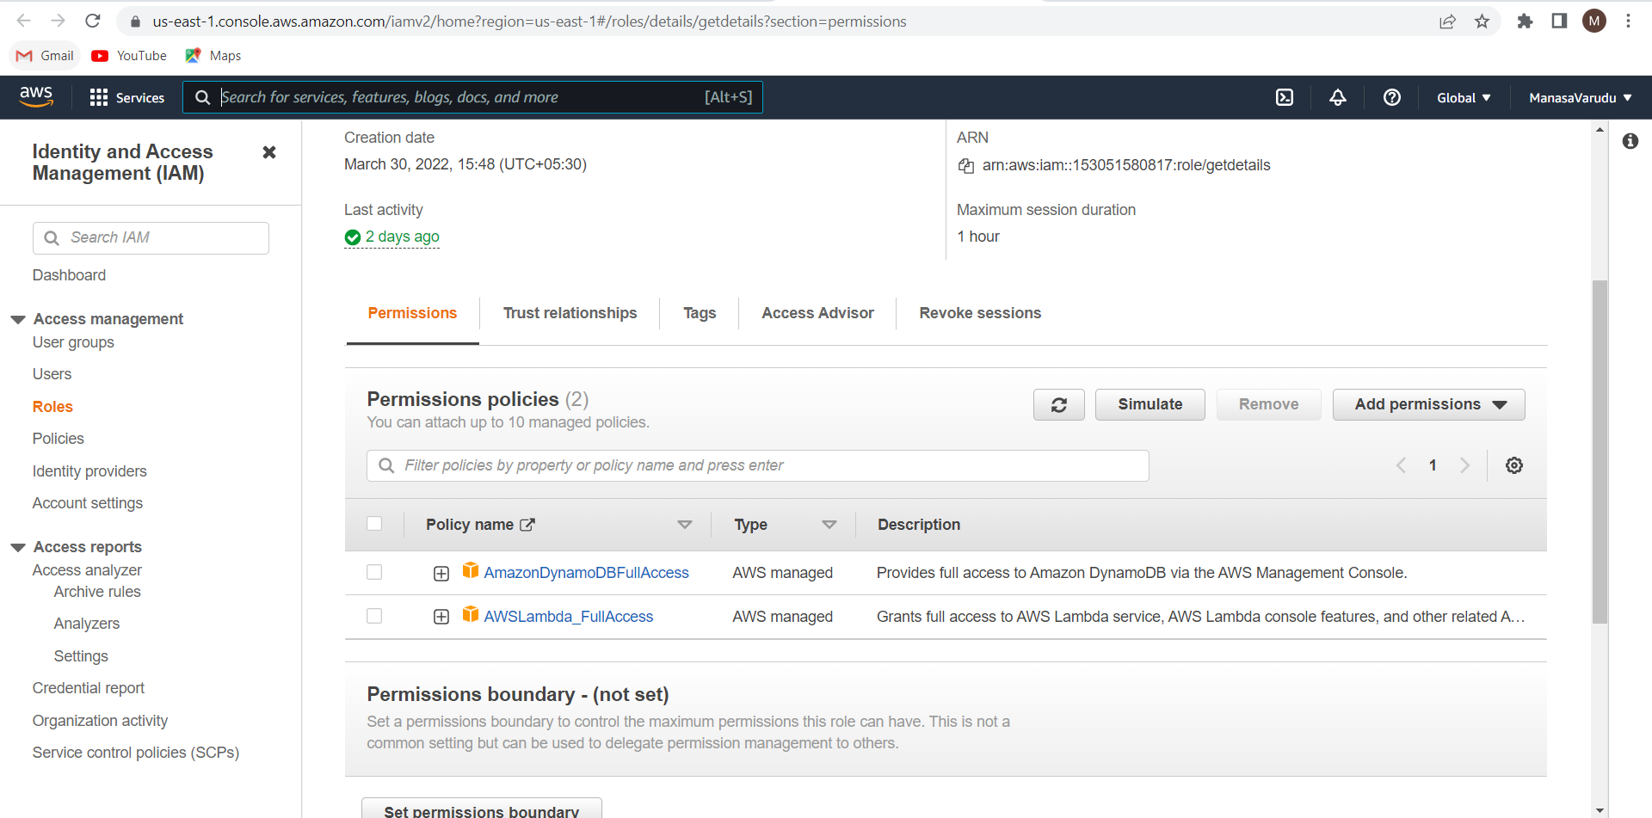

Now go to lambda page and create function.

Enter the details as shown in the below image.

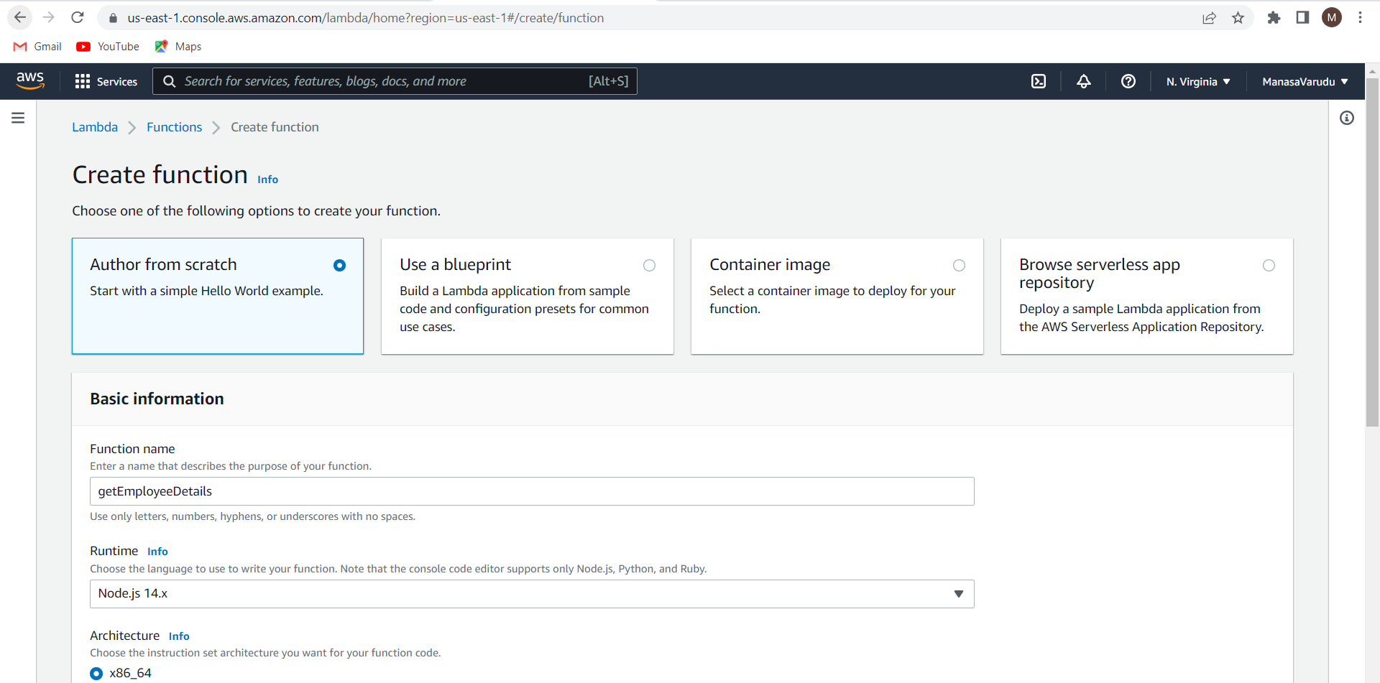

Give the IAM role that you have previously created and create a function.

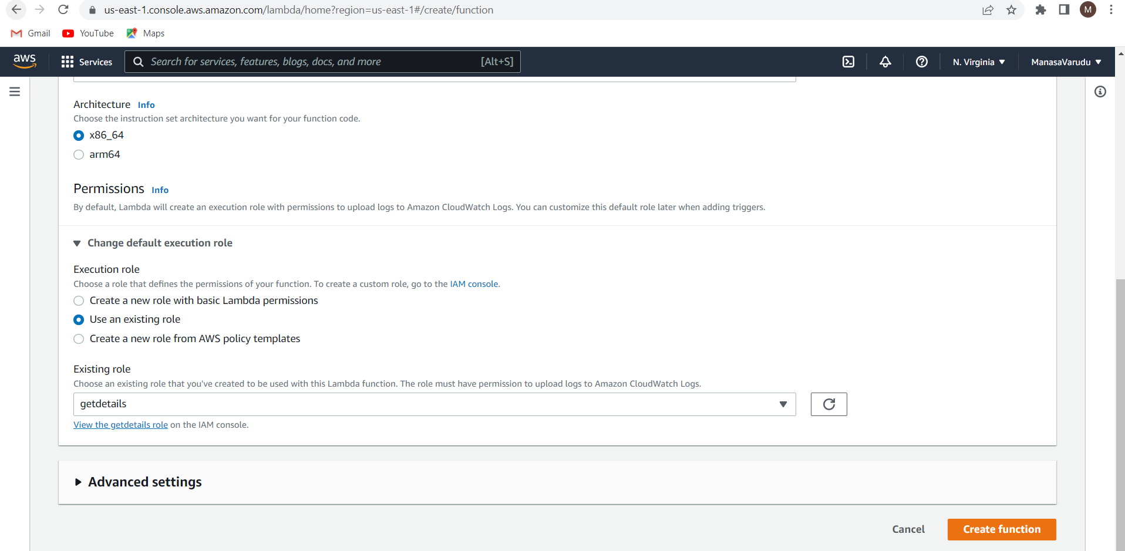

const AWS = require('aws-sdk');

var docClient = new AWS.DynamoDB.DocumentClient();

var tableName = "CustomerDetails";

exports.handler = (event, context, callback) => {

console.log(event.EmailID)

var params = {

TableName : tableName,

Key:{

"EmailID" : event.EmailID

}

}

docClient.get(params, function(err,data){

callback(err, data);

})

};

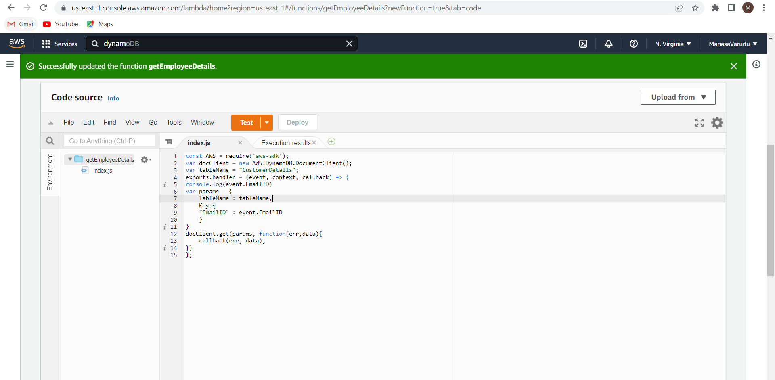

Click on test 🡪 Configure the test event.

Enter the email ID you want to fetch from the DynamoDB table. And click on create event.

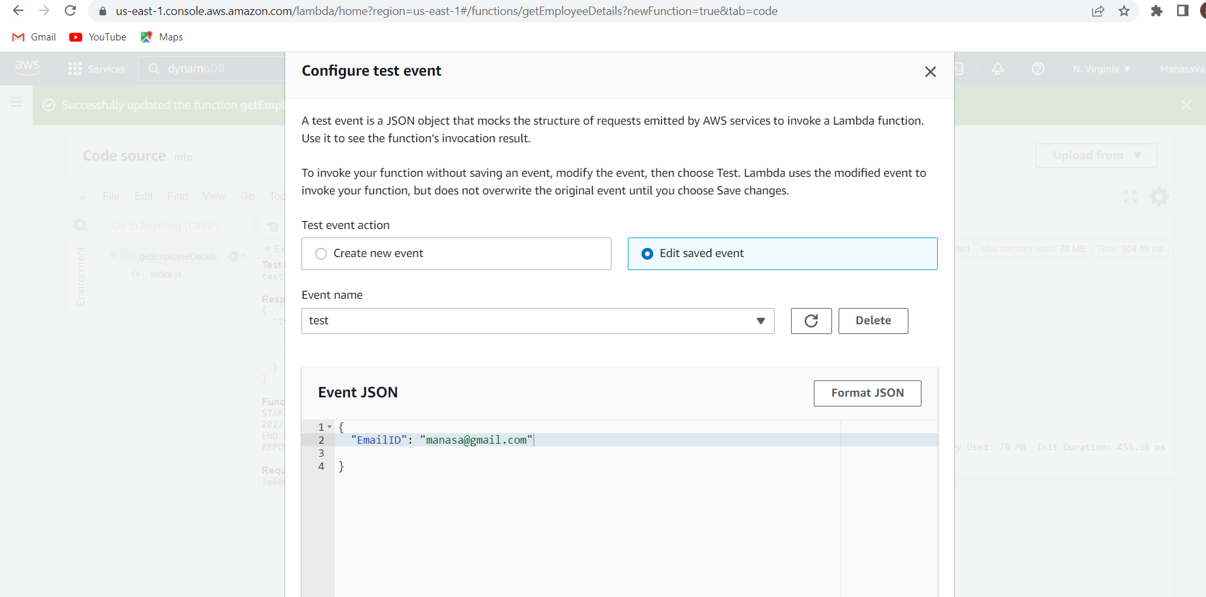

Click on test.

The data of the given EmailID is fetched.

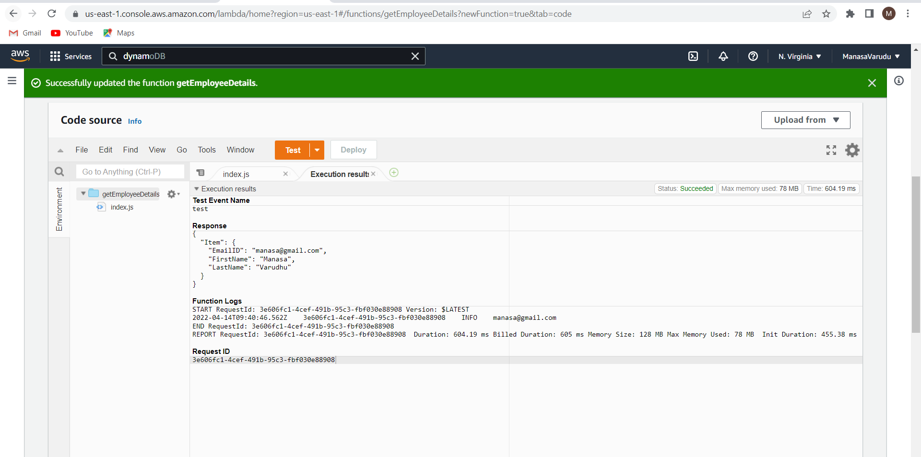

Now we will integrate this lambda function with the API gateway.

Now got API Gateway page . Click on get method and click on integration request.

Choose integration type as lambda and choose the respective function and click on save.

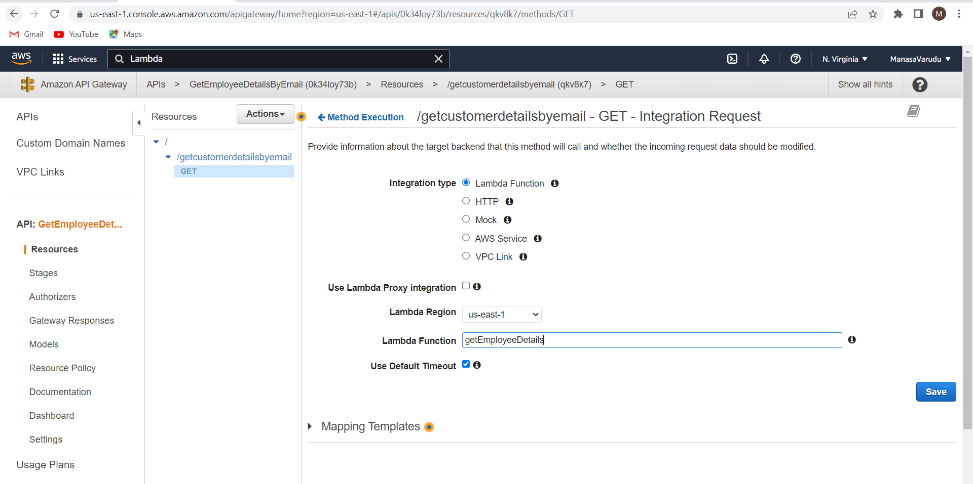

Now go to method request page . Under URL Query string parameters . click on add query string as shown in below image

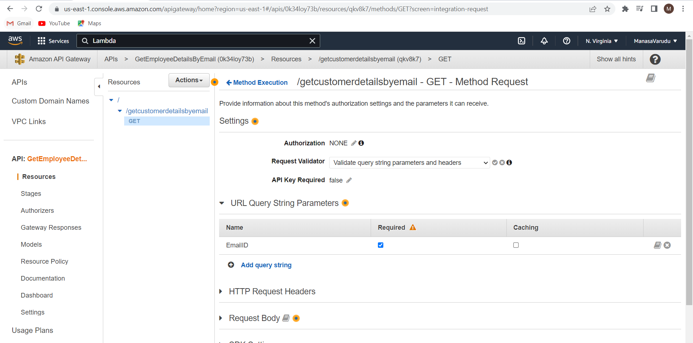

Now go to integration request , under mapping templates edit the application/json file as shown in below image. Click on save.

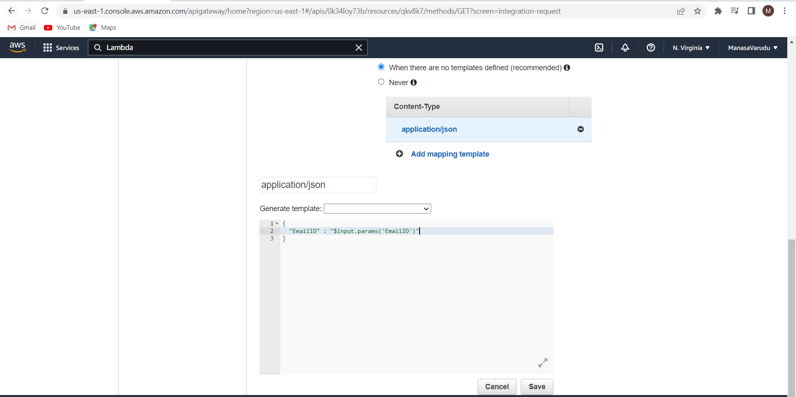

Deploy the API.

Again test the invoke url in the postman web .

Under the params give the EmailID you want to fetch and click on send.

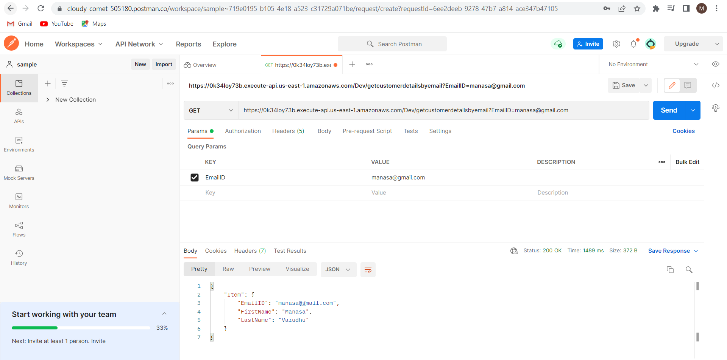

The data is fetched.

Now edit the index.html

Paste the invoke url in the javascript function as shown below and save the file.

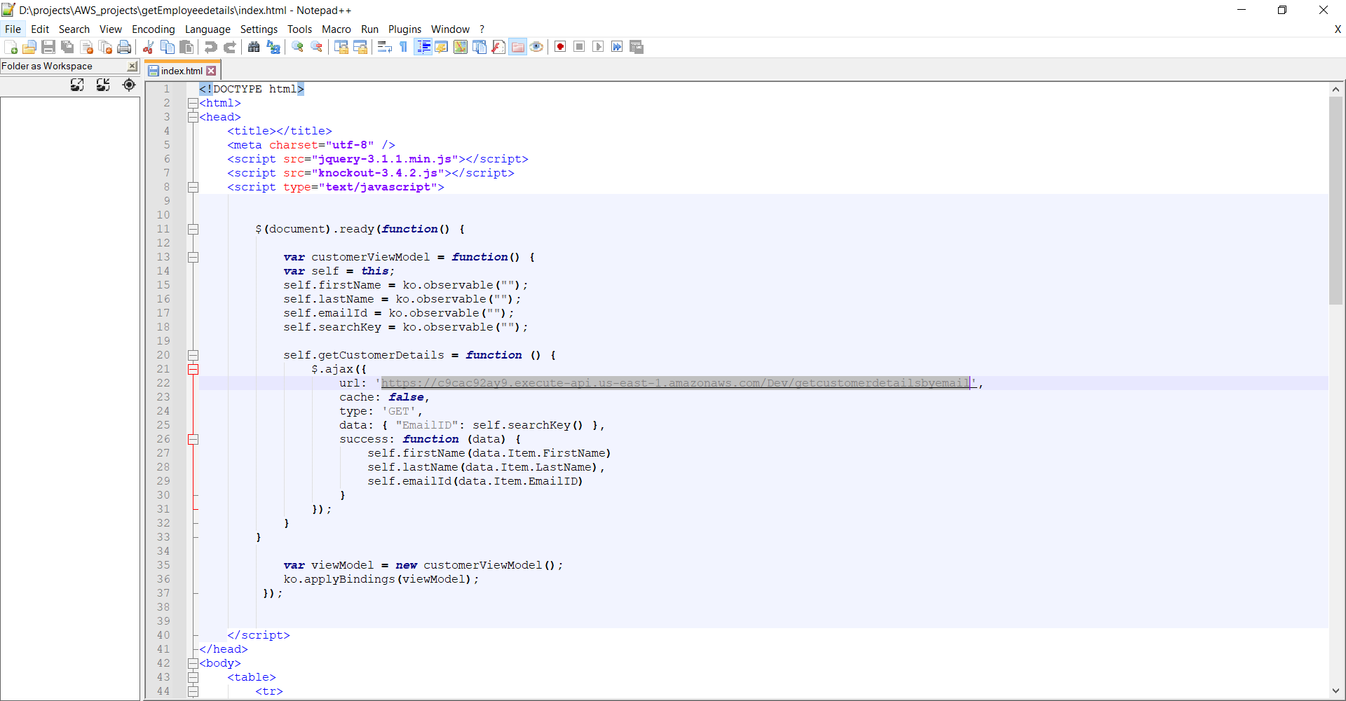

**POST Employee Details:**

Go to AWS API Gateway page and create a new API.

Build a new REST API as shown in the below image.

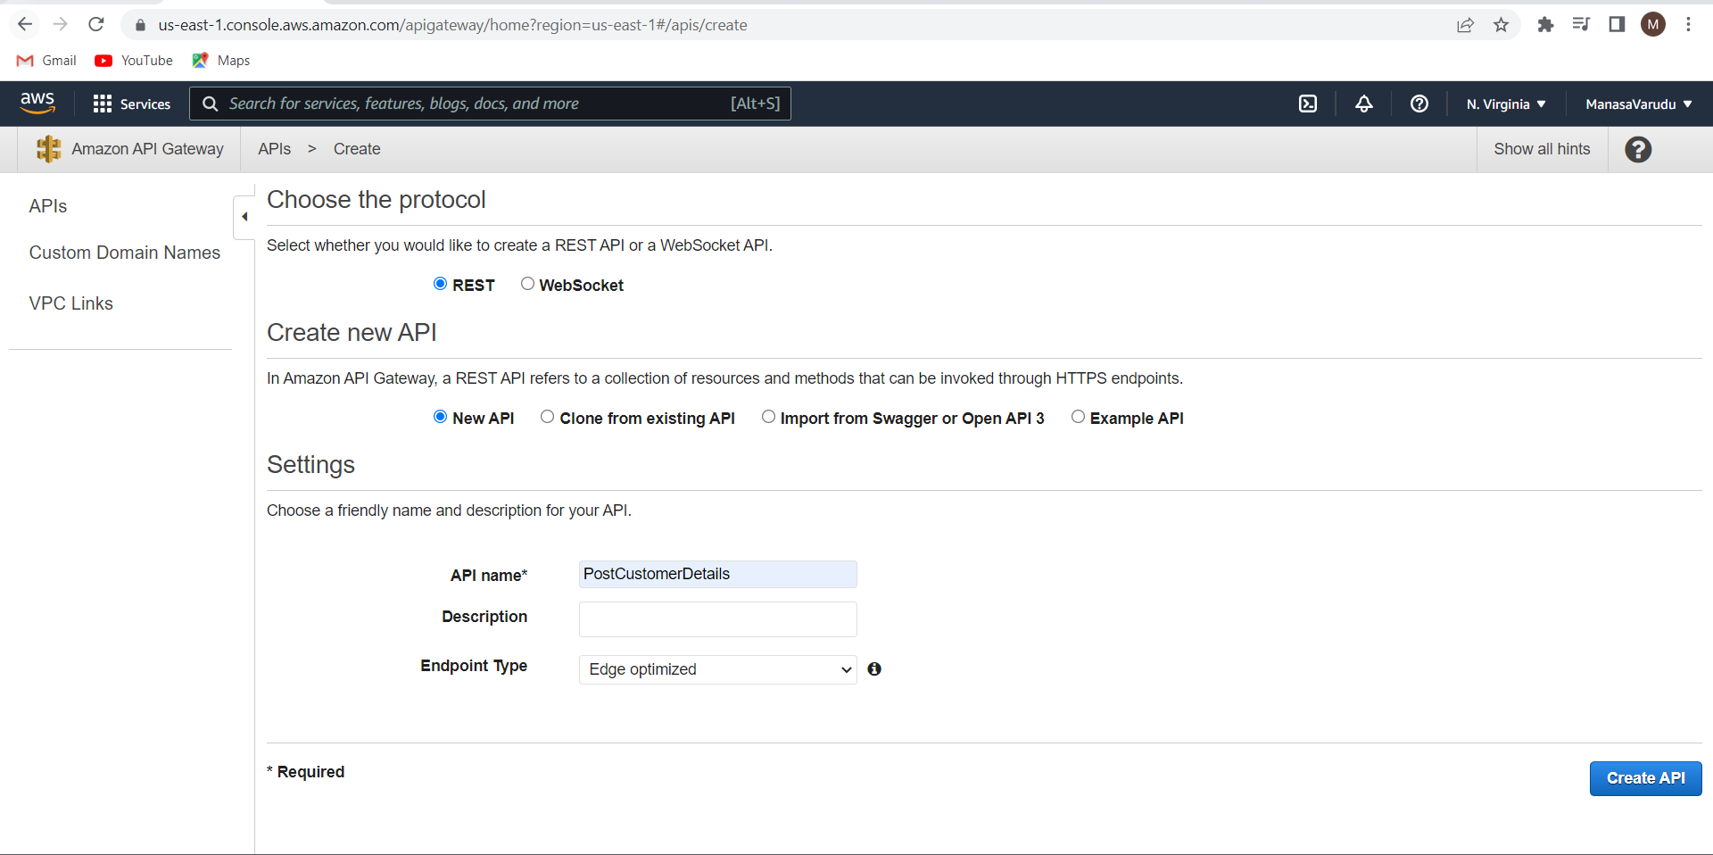

From the Actions dropdown click on create resource.

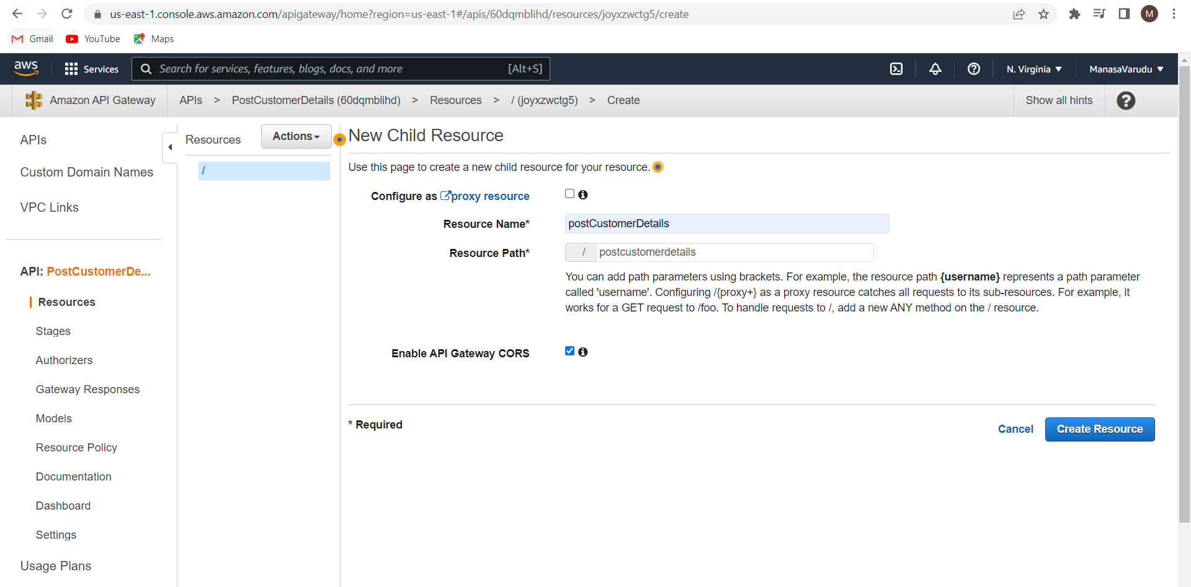

Create POST Method

Go to integration response and under mapping templates edit the application/json as shown in the below image.

Click on save

Deploy the API

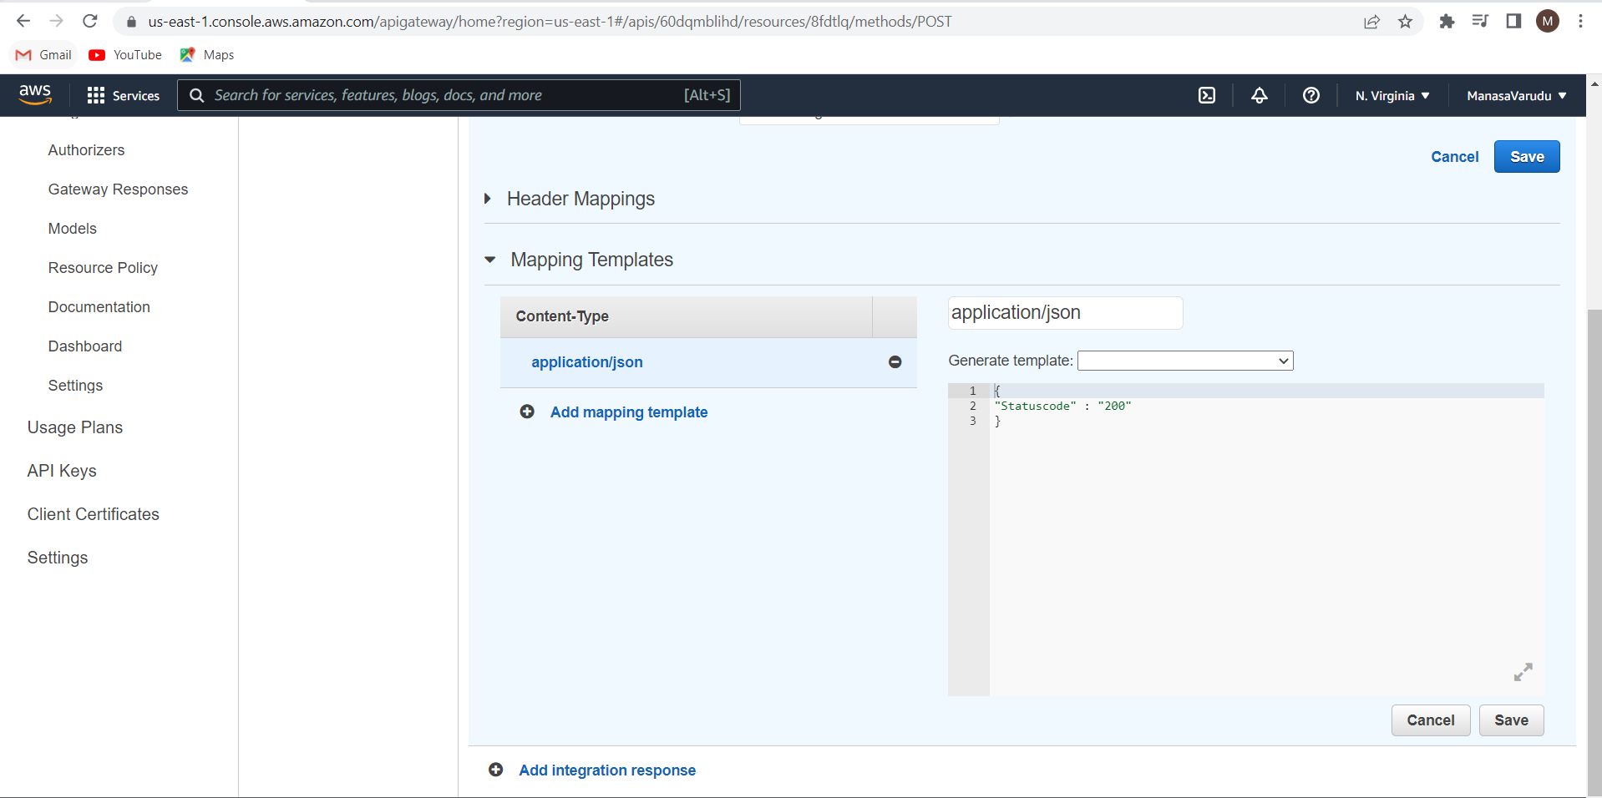

Test the invoke url in the web postman software.

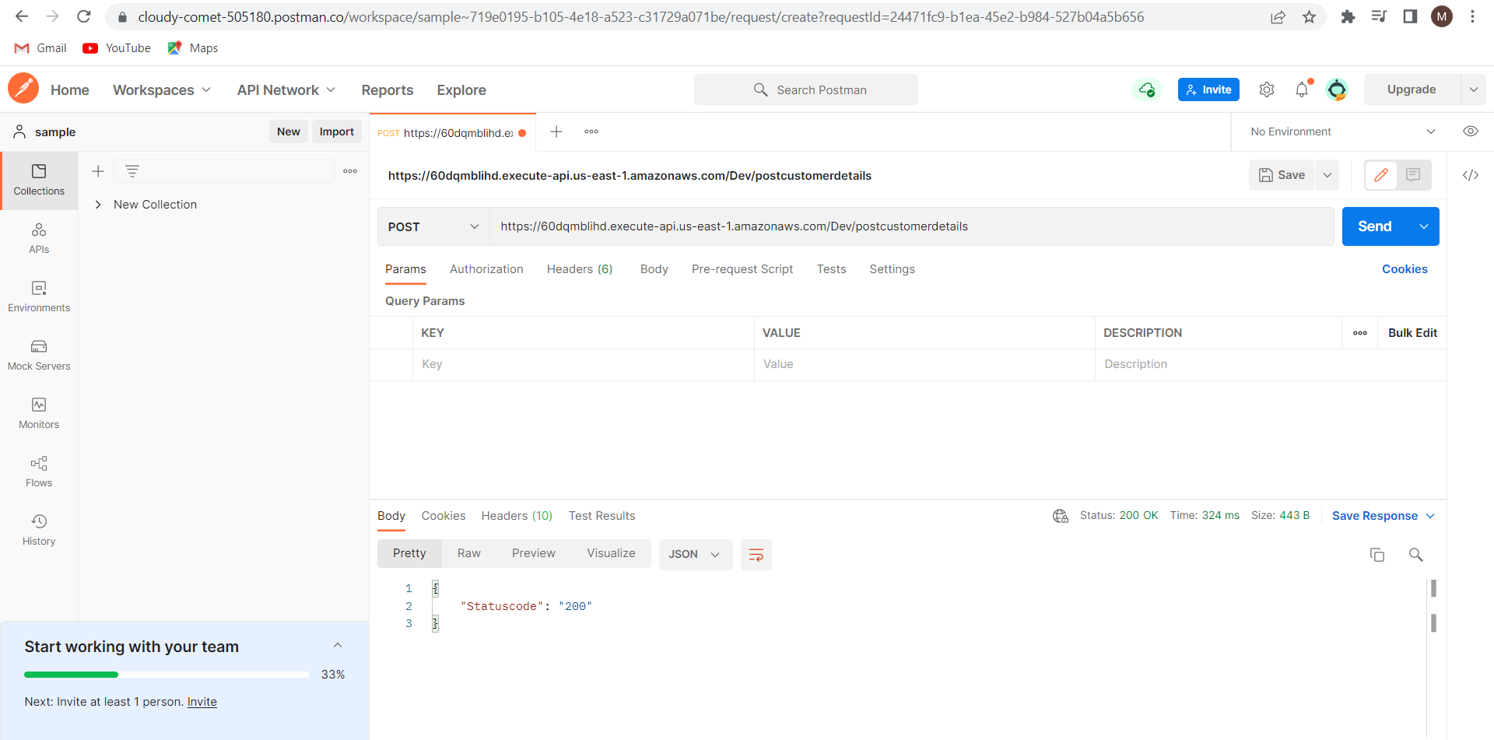

This indicates that your API Gateway is working fine

Create IAM Role with the permissions shown in the below image.

We will use this role in the Lambda function creation.

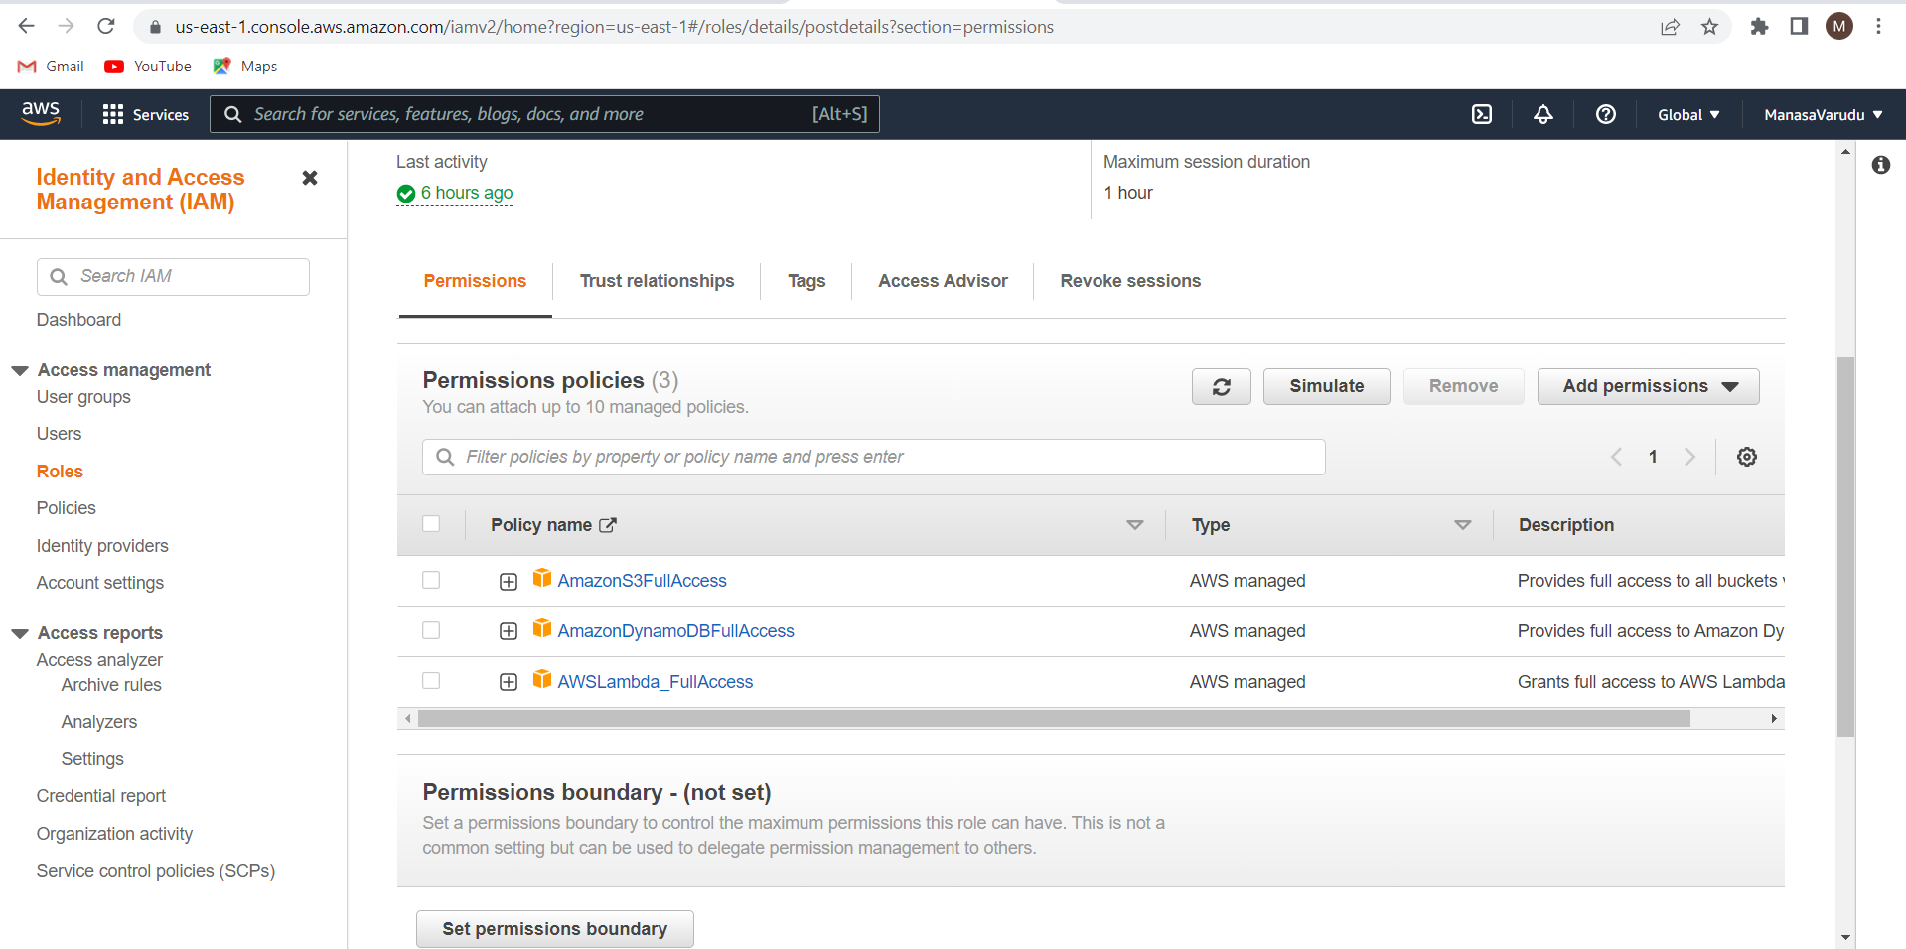

Go to Lambda page.

Now we will create a new function that posts the details in to the DynamoDB table.

Enter the details of the function as shown below

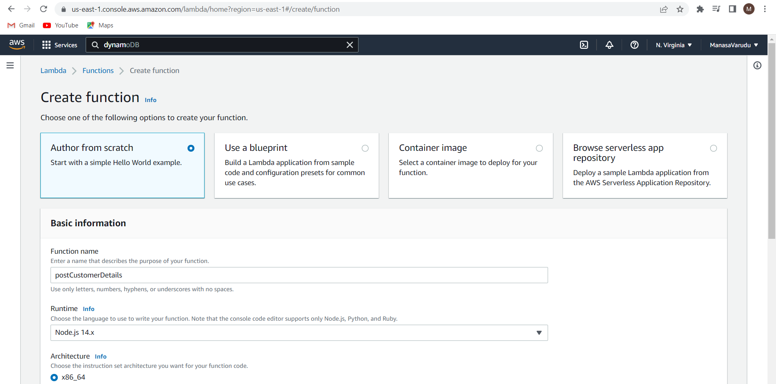

I have selected the IAM role as postdetails which I have created earlier.

Click on create function

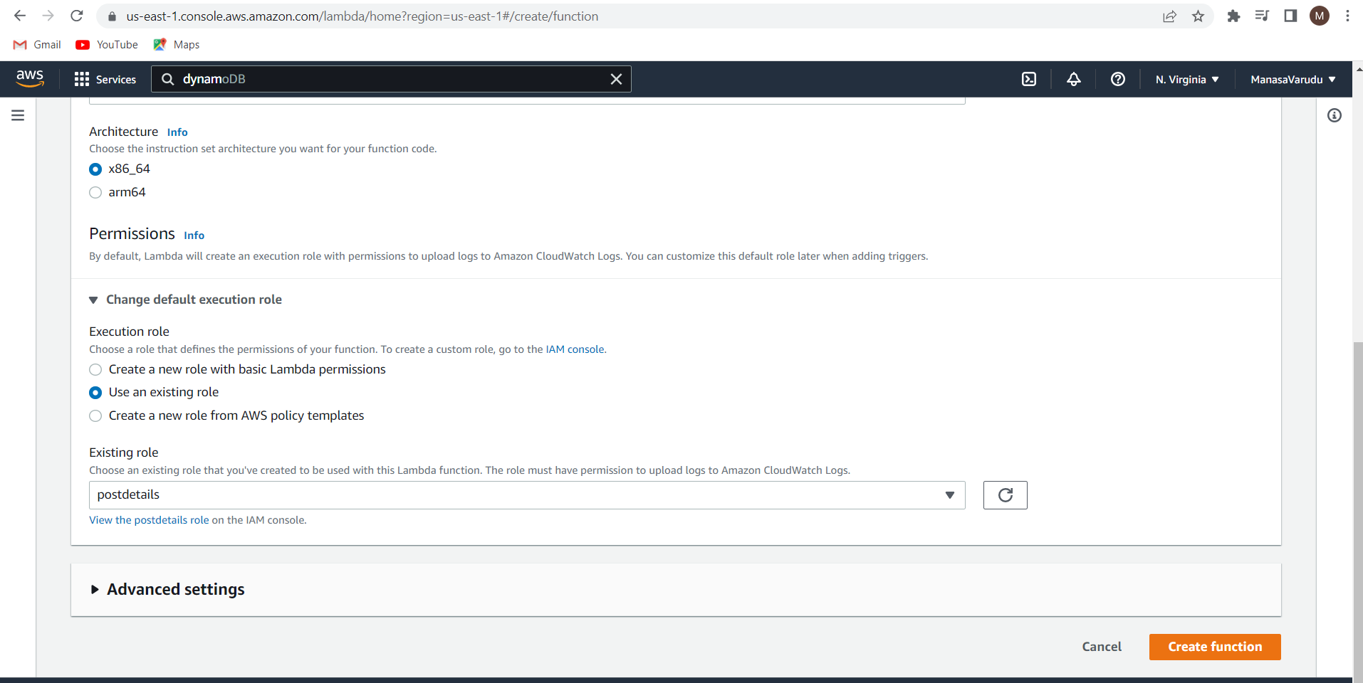

const AWS = require("aws-sdk");

var docClient = new AWS.DynamoDB.DocumentClient();

exports.handler = (event, context, callback) => {

var tableName = "CustomerDetails";

var params = {

TableName : tableName,

Item:{

"EmailID" : event.EmailID,

"FirstName" : event.FirstName,

"LastName" : event.LastName,

}

};

docClient.put(params, function(err,data){

callback(err, data);

}else{

callback(null,"sucessfully updated data")

}

})

};

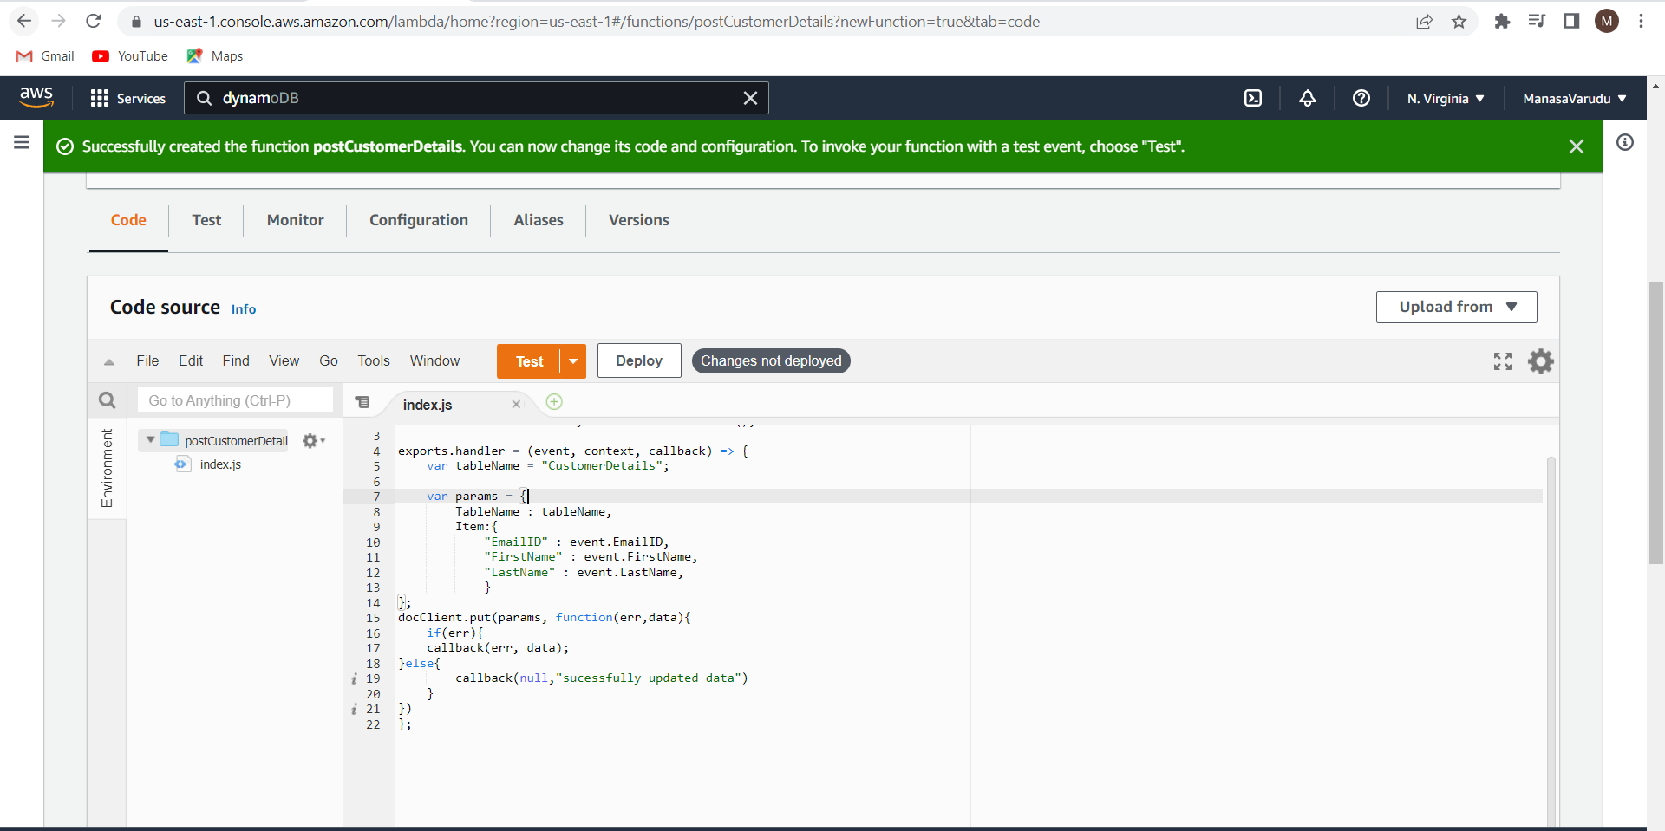

Create a new test event by entering the details that are need to be pushed into the dynamo DB table in the json format

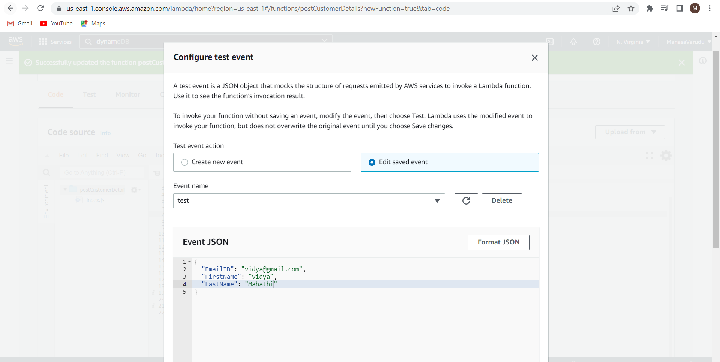

Test the lambda function.

We can see that the function is executed successfully.

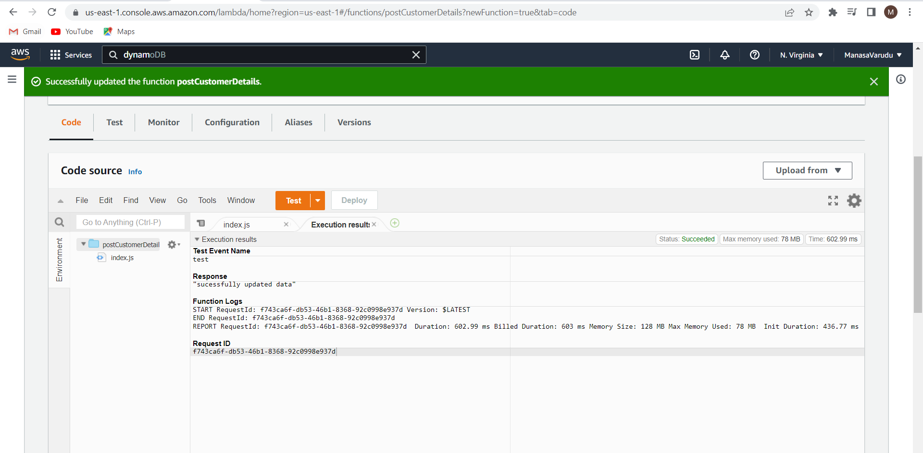

We can see that the data we given is entered into the dynamo DB table.

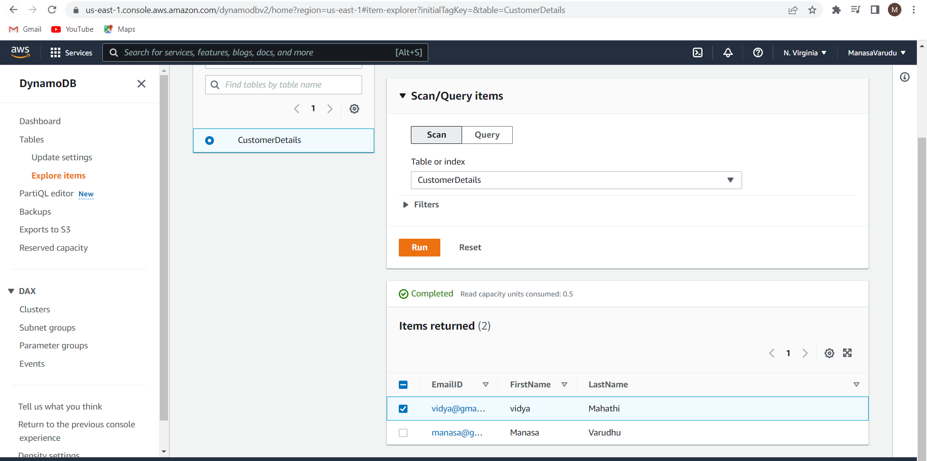

Now we will integrate the Lambda function to the API Gateway.

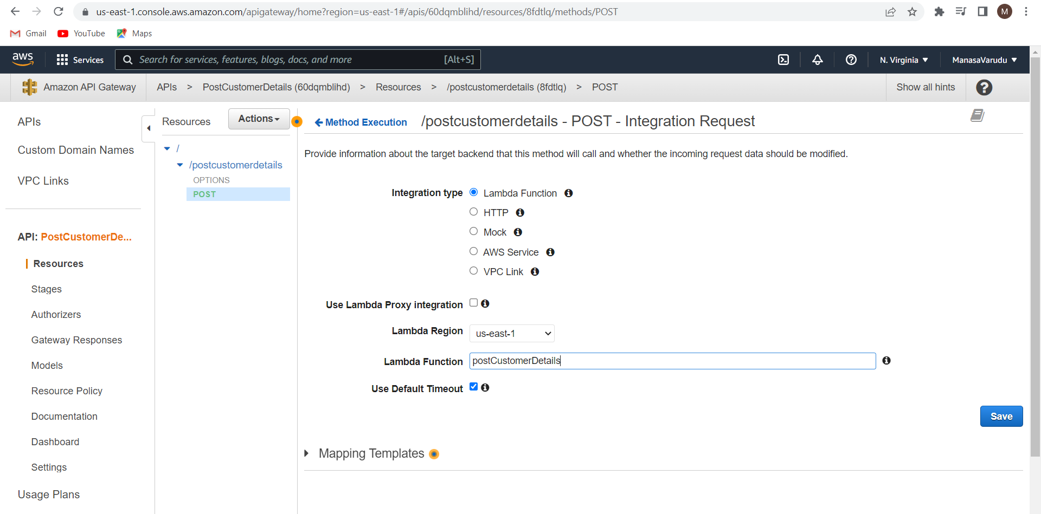

In the Integration response page clear the application/json and click on save.

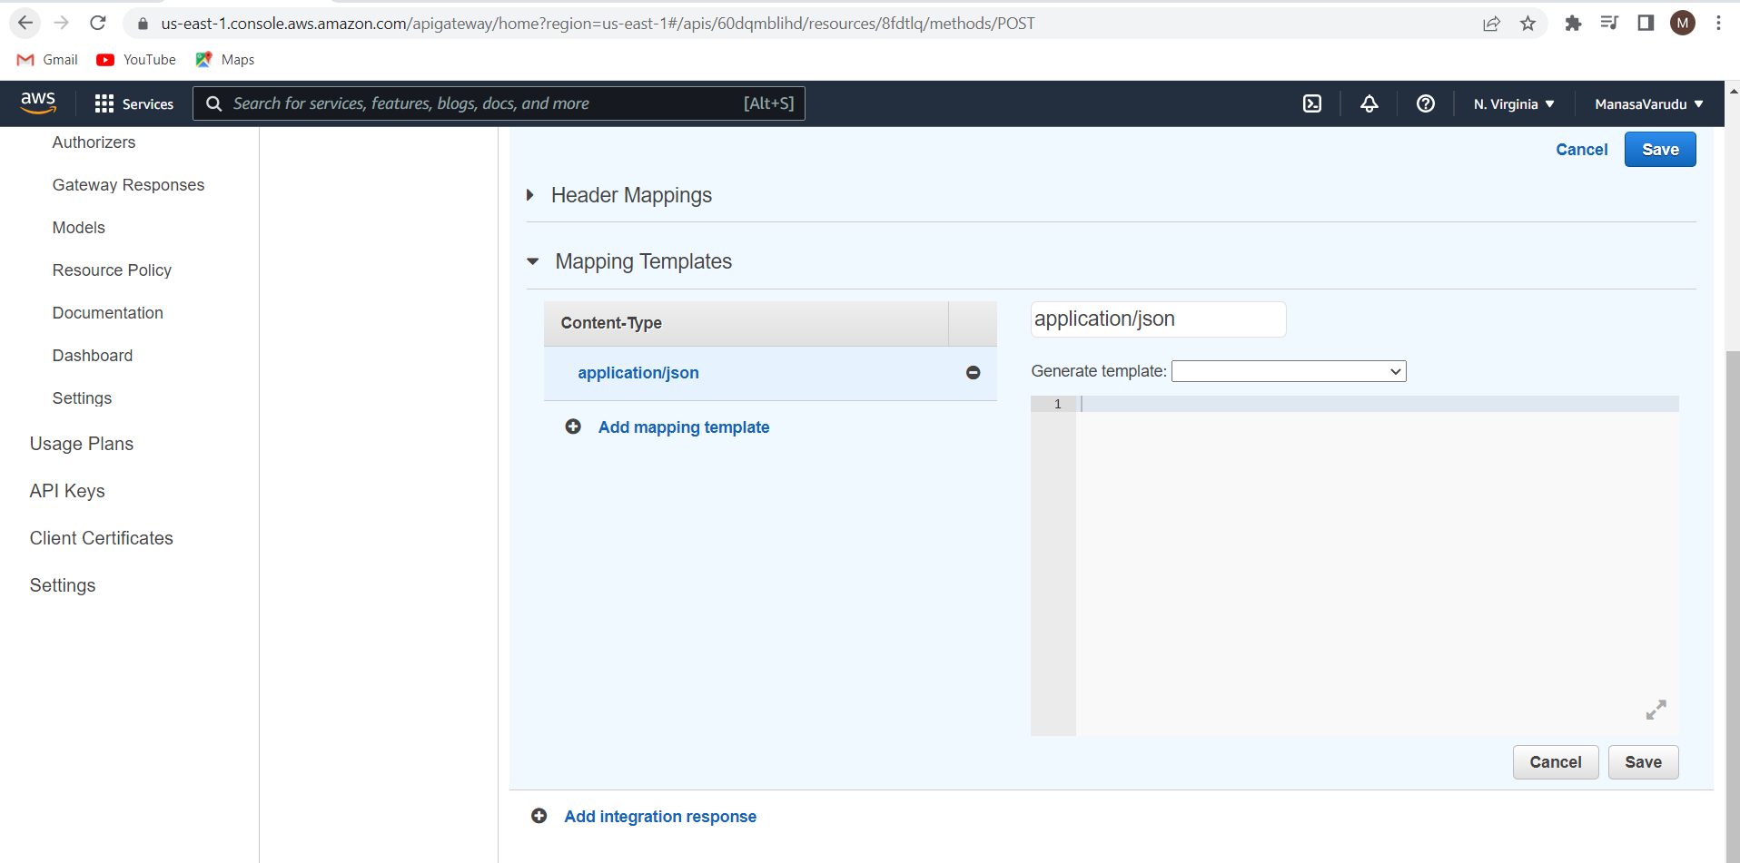

Deploy the API

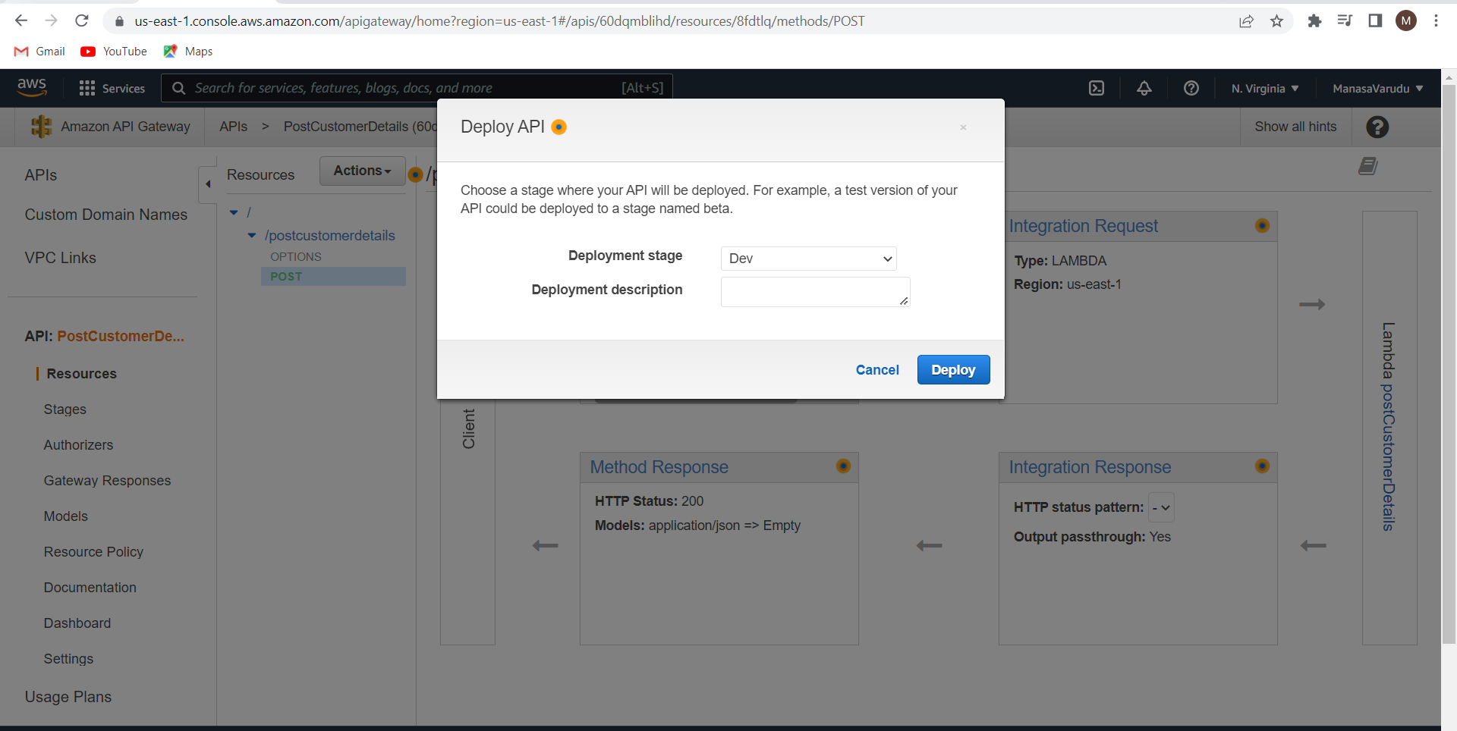

Copy the invoke url.

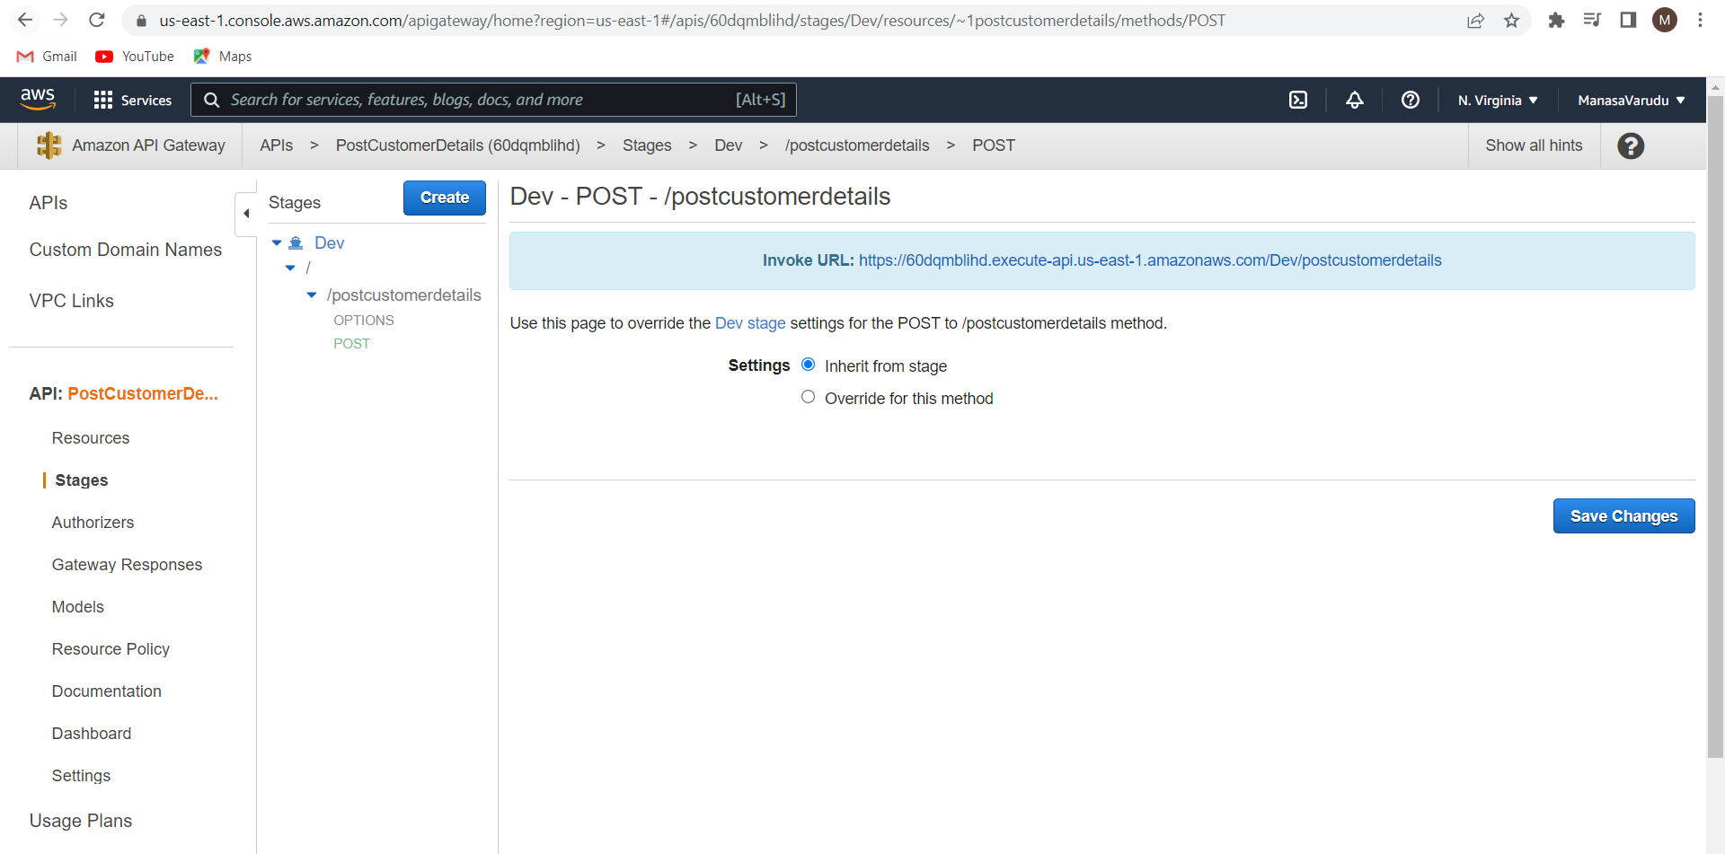

Paste the invoke url here.

Give the data in the json format that is needed to be entered in the DynamoDB table.

Click on send

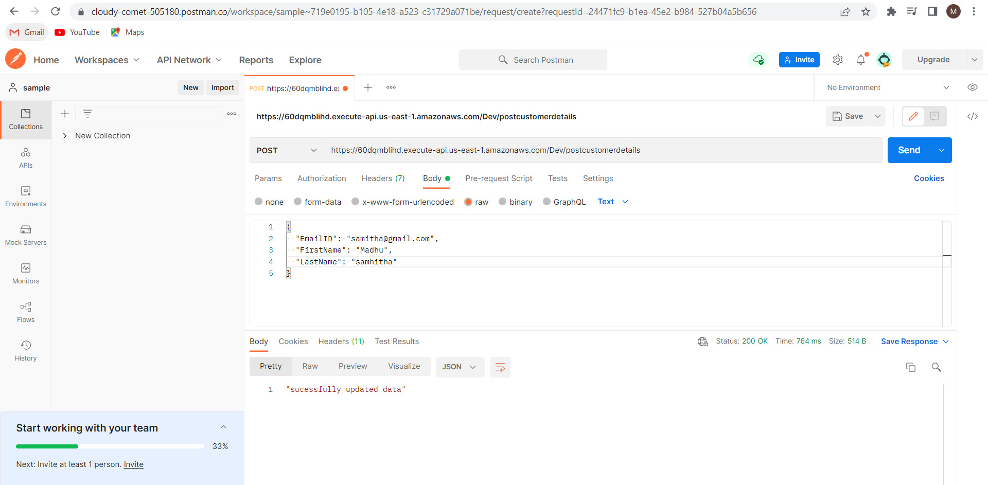

We can see that the data is successfully updated.

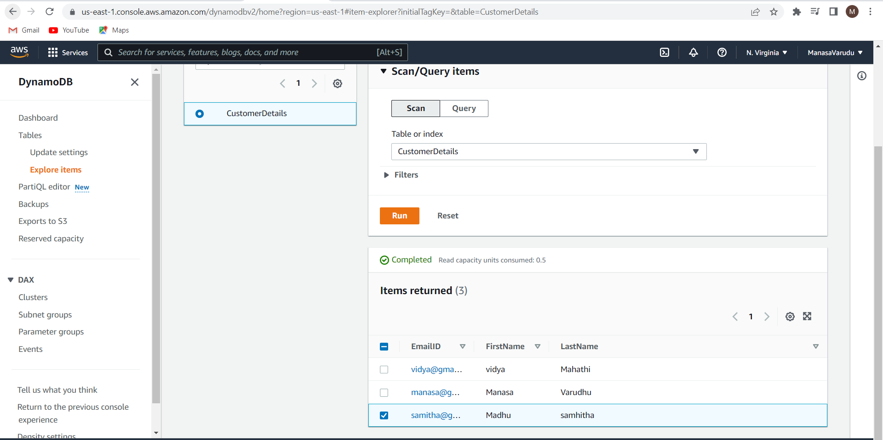

Copy the invoke url in the index.html page. Save the file.



Host your website in the S3.

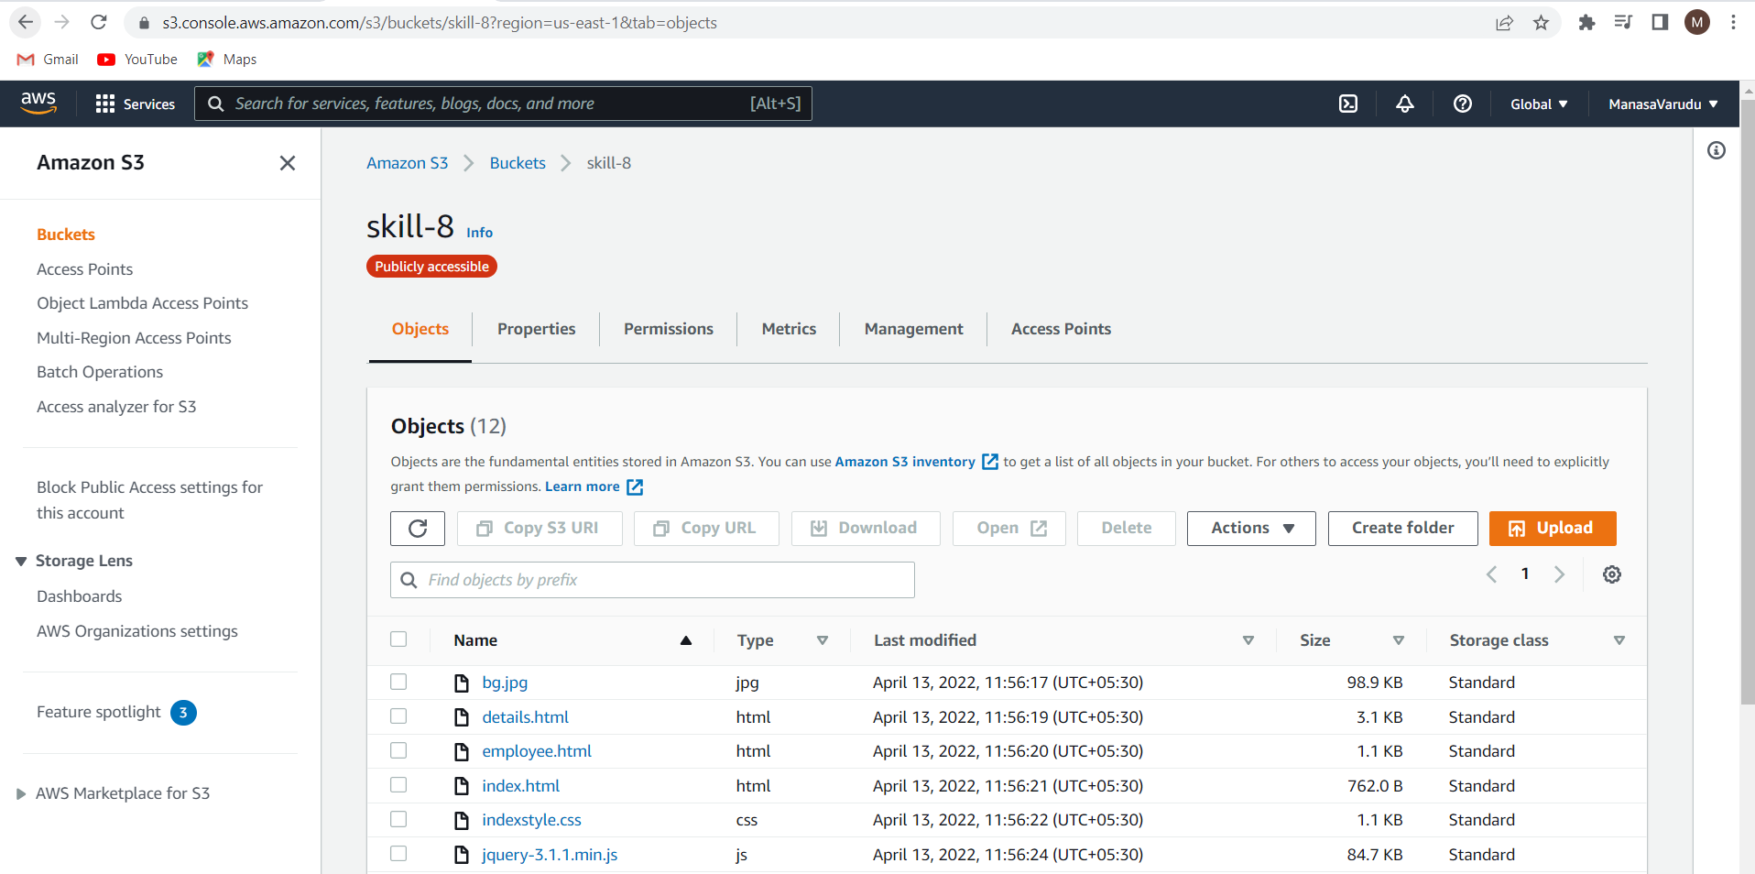

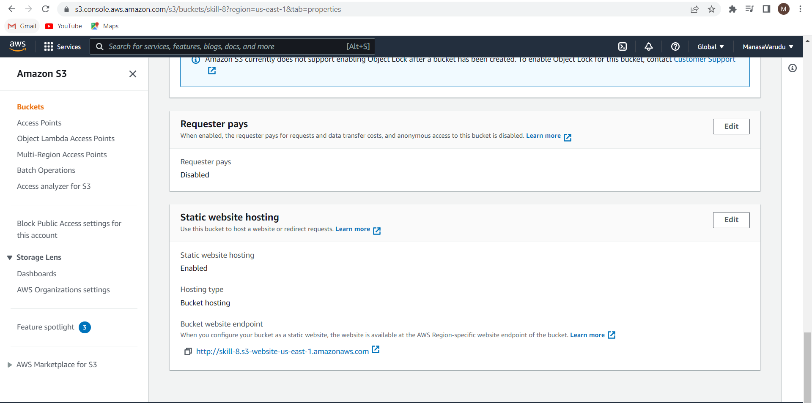

Copy paste the s3 static webhosting url in the browser.

Here I have mapped my website to Route 53 with the domain manasa27.ml

**Execution:**

Enter the details and click on save.

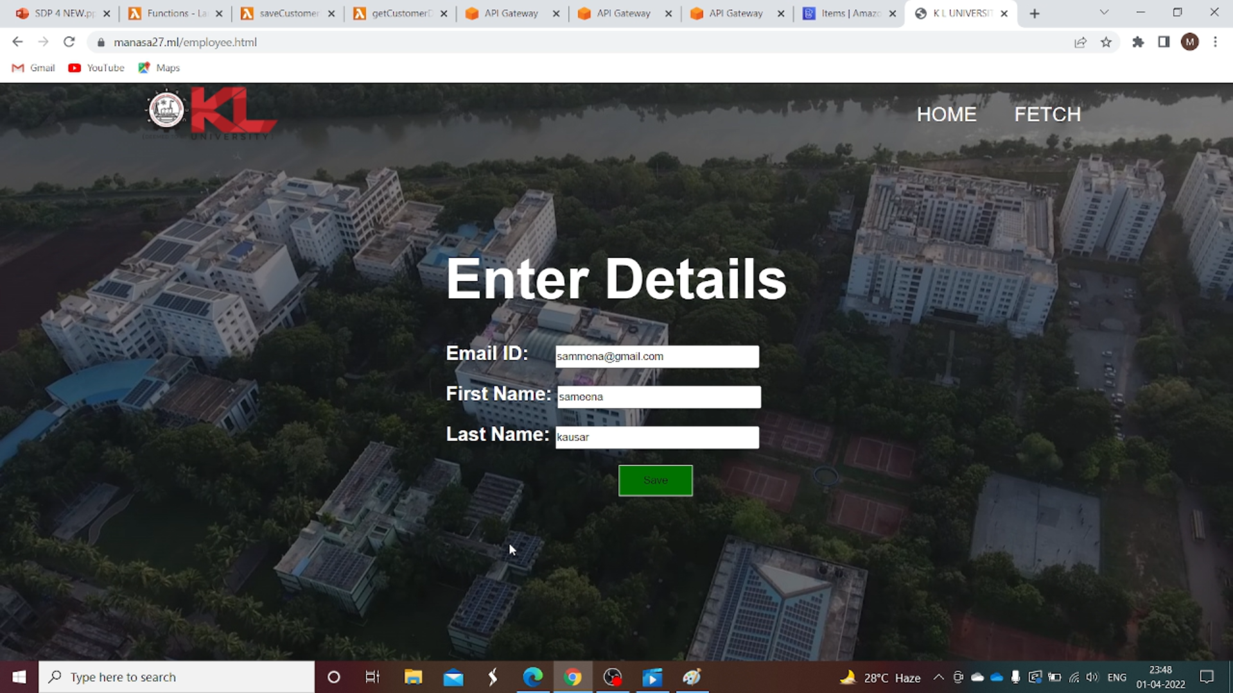

The message shown that the details are successfully updated.

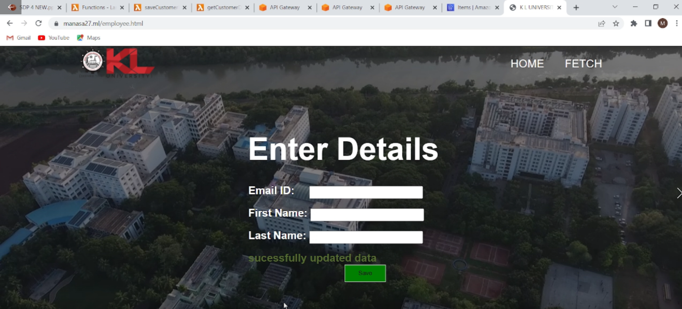

Let us check the dynamo DB table whether the details updated or not.

The given details are successfully updated in DynamoDB Table

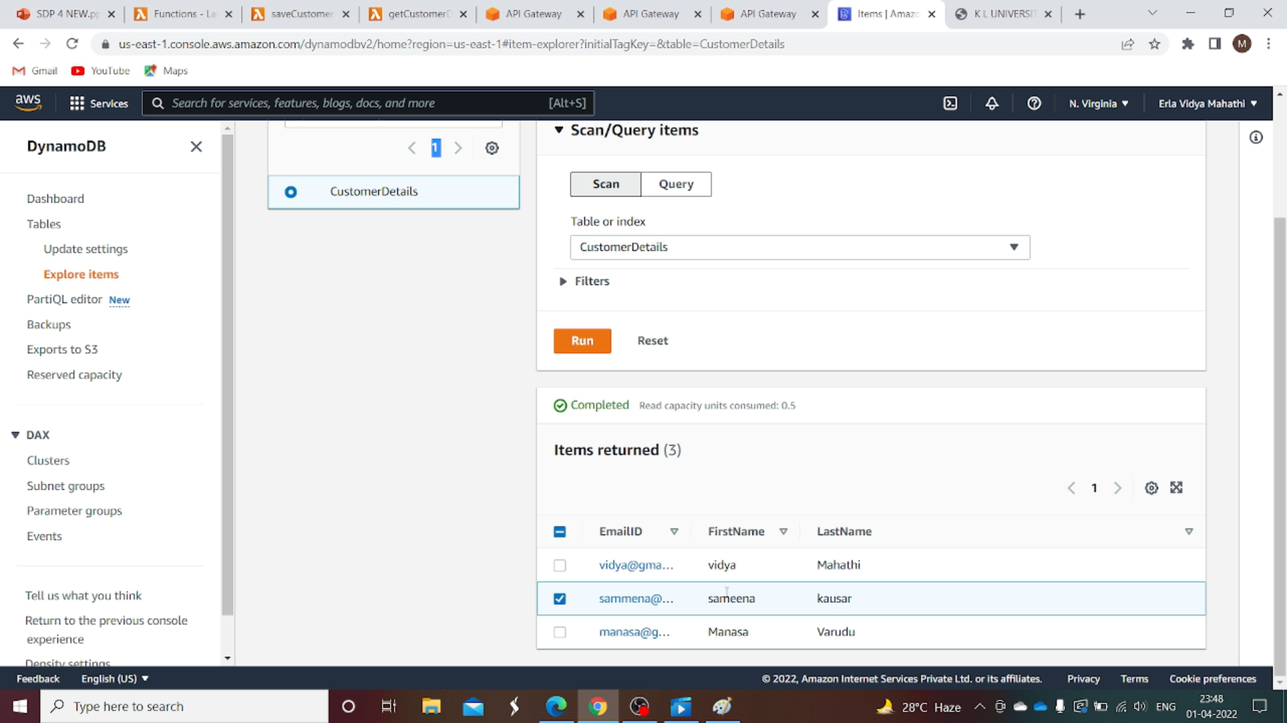

Enter a Email ID and click on get.

If the Email ID is present in the table the details will be fetched.

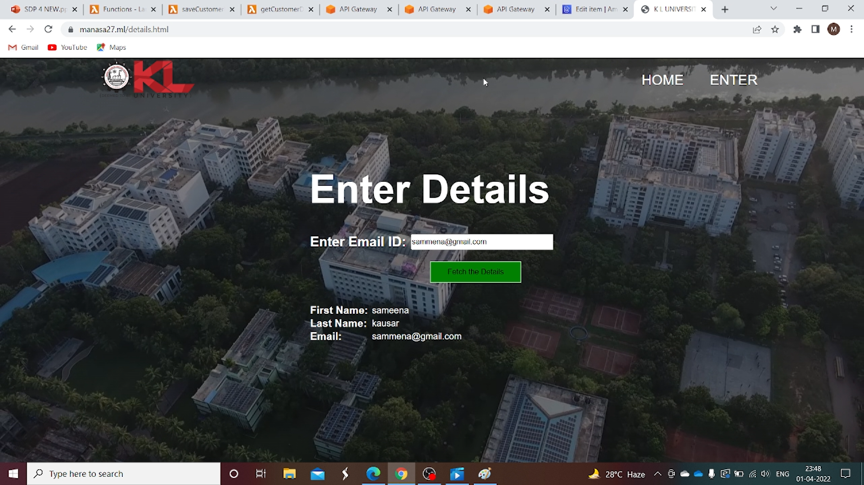

THANK YOU